Real Time Face Recognition System for Classroom Attendance
Guillermo Garcia de Celis, Kevin Truong
Lawrence Technological University

Dr. Mohammad Mezaeell
MCS 5719 Deep Learning

Introduction
Facial recognition has become an important technology in modern life. From unlocking smartphones with a glance to recognizing friends in photos, it plays a role in security and convenience alike. At its core, facial recognition involves identifying or verifying a person’s identity from an image or video of their face. Our project focuses on leveraging deep learning for a class attendance system by using facial recognition to automatically mark which students are present. The goal is to design and implement a deep learning model capable of accurately identifying individuals through a camera feed in real time. Such an automated attendance application can be helpful as it can save time in classrooms and reduce manual errors.
Deep learning has proven to be one of the most effective approaches for facial recognition. Traditional methods like eigenfaces or hand-engineered features have largely been surpassed by convolutional neural networks that learn directly from large datasets of face images. By looking into these advancements, our project aims to build a system that recognizes students' faces on the fly. In the following sections, we outline existing work in the field, the theoretical concepts behind our approach, the methodology and experiments we conducted, an analysis of our results, and the final insights and future directions for the class attendance facial recognition system.

Literature Review
Facial recognition has been a subject of research for decades, but the discovery of deep learning has dramatically improved its accuracy and reliability. Modern facial recognition systems typically involve two main stages: face detection (finding and isolating faces in an image) and face identification (determining who the face belongs to). Earlier systems often used classical algorithms for detection (like Haar cascades) and recognition (like PCA-based eigenfaces). However, modern systems use deep neural networks for both tasks due to their performance.
In this project, we used two deep learning models in face recognition: FaceNet and VGGFace. FaceNet explores the concept of training a CNN using triplet loss to directly learn an embedding of faces into a high-dimensional space. The result is a 128-dimensional feature vector for each face, such that faces of the same person are close together in this space and faces of different people are far apart. FaceNet achieved groundbreaking performance (reportedly ~99.63% accuracy on the Labeled Faces in the Wild benchmark) by using this embedding approach rather than a traditional classifier. VGGFace on the other hand, is based on the VGG-Very-Deep-16 CNN architecture. It was trained on a large dataset of face images to classify and the learned representations. VGGFace achieved high accuracy as well, though slightly below FaceNet.
Key Challenges: Despite these powerful models, implementing face recognition in a custom scenario (like a classroom) has challenges:
- Data scarcity: Deep learning models demand a lot of data. However, in a class attendance scenario, we might only have a few images per student. This imbalance makes training a model from scratch very difficult. We faced this issue trying to train a CNN on a limited set of student photos led to poor performance.
- Overfitting: With a small dataset, complex models can overfit, meaning they memorize the training faces but fail to generalize to new images. We observed overfitting when using a straight CNN classifier approach.
- Pre-trained models vs. custom models: Using pre-trained models (like FaceNet or VGGFace) help us decrease data issues, since those models have learned from huge face datasets. This is called transfer learning and it was demonstrated to be extremely effective with small-datasets.
- Similarity vs. classification: An important concept from prior research is that face recognition can be treated as a similarity comparison problem instead of a multiclass classification problem. Models like FaceNet emphasize learning a good feature space for similarity comparison.
Our project builds on these insights: we attempted a classic CNN classifier and then pivoted to a similarity-based approach using FaceNet, in line with what recent research suggests for better robustness.

Theoretical Framework
Before going into details about our project, it’s important to understand the theoretical concepts:
- What is Facial Recognition? – In this context, facial recognition refers to the automated identification of a person from an image of their face. There are two closely related tasks: verification and identification. Our project leans more towards identification, since we want to recognize which student from our class appears on camera.
- Feature Vectors (Embeddings): Modern face recognition models convert face images into numerical feature vectors. This vector is often called an embedding. In our project, we used FaceNet to generate a 128-dimensional embedding for each face. The idea is that this embedding captures the unique facial features of a person in a way that is machine-comparable. Two images of the same person should have similar embeddings, while images of different people have very different embeddings.
- Cosine Similarity: To decide if two face images belong to the same person, one common metric is cosine similarity. Cosine similarity measures the cosine of the angle between two vectors. Given two feature vectors a and b, each of length 128 in our case, the cosine similarity is defined as:
$cosine_sim(a,b)=\frac{∥a∥∥b∥}{a⋅b}​$
This formula essentially compares the orientation of the two vectors. A cosine similarity of 1 means the vectors point in exactly the same direction (perfect match), 0 means they are orthogonal (totally unrelated), and -1 would mean opposite directions. In face recognition, we expect two images of the same person to have a cosine similarity close to 1, whereas two images of different people should have a lower similarity.
- FaceNet: Usually, CNN classifiers need a lot of images per person to correctly identify them because they directly predict who the person is from the image. But our dataset is very limited, FaceNet solves this problem by turning faces into special vectors called embeddings. Instead of trying to directly classify different faces to specific students. FaceNet places similar faces close together in an embedding space. This makes identifying faces easier, even when you have very few examples.

Methodology
Our approach changed over the course of the project as we learned from our mistakes. Here we describe the methods and tools used:

Initial Attempt: CNN Classification
At first, we attempted a more conventional deep learning approach treating the problem as a multi-class classification of faces. The idea was to train a convolutional neural network that takes an image of a face and directly outputs the predicted person’s name. We proceeded with the following steps initially:
- Data Collection (Initial Phase): We gathered images of the individuals (students) we wanted to recognize. This included:
  - Profile Pictures: Each student’s profile photo from Canva. In total, our dataset at this stage was relatively small. For each student, we had only 1 picture for each student.
  - We also used Labeled Faces in the Wild (LFW) as additional training data. LFW is a public dataset with thousands of celebrity photos.
- Data Cleaning and Augmentation: For each of the image of our classmates, we applied data augmentation to artificially increase the number of training samples for each student.
- Model Choice and Setup:
  - CNN Classifier: We initially experimented by building our own custom CNN from scratch. The idea was to train this CNN on the LFW dataset and then fine-tune it to classify the students in our class using a deep neural network approach.
  - VGG16 / MobileResnet : We also experimented with using pre-trained CNN architectures as a starting point, specifically VGG16 (the base of VGGFace) and MobileResnet . The idea was to use these networks with their weights pre-trained on ImageNet, then add a new classifier layer for our set of students.
The training was done using TensorFlow/Keras. We split our augmented dataset into a training set and a validation set to look at the performance on unseen images of the students. We trained the model using categorical cross-entropy loss and monitored accuracy on training vs validation. We used small batch sizes (16) because of the small dataset, and trained for a number of epochs, we tried 10, 20 and 30 while watching for overfitting signs. We also used techniques like Early stopping to stop training if validation loss stopped improving.
The result of this initial approach seemed good during training and validation, as the model reached high accuracy on both datasets. However, when putting the model into a real-world test through a live stream and placing our faces in front of the camera, it failed to recognize us. Instead, the model often randomly classified people, showing that despite good training and validation metrics, the model did not generalize well to real-life conditions. This showed us that even though the model performed well on the training and validation images, it did not truly learn how to recognize faces in different real-world conditions. It was mainly memorizing the training images instead of learning real features of the faces. We realized that we simply didn't have enough images per class. Using VGG16 and MobileNet pretrained models led to the same results, as we needed to pair these pretrained models with a classification layer in order to recognize the students. So, because of the problem mentioned above, Given the above problems, we decided to change course.

Revised Approach: FaceNet Embeddings & Similarity Comparison
For the new approach, we decided to use a new pre-trained model for feature extraction (FaceNet) and also to create a bigger dataset.
- Using FaceNet via Keras-FaceNet: We installed and imported the keras facenet library. This model comes pre-trained and when given an image of a face, it outputs the 128-d embedding vector. With FaceNet, we no longer need to train the deep network on our data. We paired that with MTCNN for face detection.
- Building a bigger Database: In class, we took additional images of each student, capturing 4 pictures per person. We also applied some data augmentation techniques, which allowed us to create more images under different environments and lighting conditions.

How did it work?
- For each picture, run it through the face detector and FaceNet to get the embedding vector.
- Store that vector in a Python dictionary or list with the key being the person’s name. This collection of vectors with labels constitutes our reference database. If we have multiple images of the same student, we average them to get a representative vector.
- We then developed the attendance system to work in real-time using a laptop webcam or a video feed:
- We used OpenCV (cv2.VideoCapture) to capture video frames from the camera.
- For each frame, we applied MTCNN to find faces. MTCNN returns bounding box coordinates for each face found.
- For each detected face, we cropped the face region and fed it to FaceNet to get the 128-d embedding.
- We then compared this embedding to all embeddings in our database using the cosine similarity function. We wrote a simple function that normalizes the vectors and does a dot product as described earlier.
- We found the best match among the database. If this best score was above a chosen threshold. We set 0.5 as an initial threshold, we considered it a recognition. The output of this step is essentially the name of the student with the closest embedding, and the similarity score.
- As presented in the following figure, all this process was obtained and accomplished by using FaceNet.
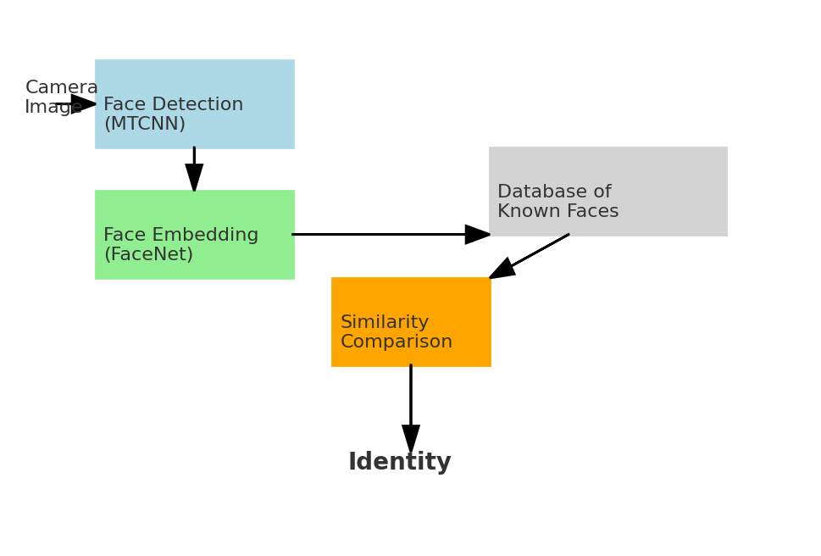
Figure 1 - FaceNet Flowchart
List Attendance Report
At the end of the recognition session, the system generates an attendance report by checking which students were successfully identified during the live camera feed. The attendance is stored in a dictionary, where each student’s name is linked to a boolean value indicating their presence. The code then loops through this dictionary and prints out a clean summary. For each student, if the system detected and recognized their face at any point during the session, they are marked as “Present”; otherwise, they are marked as “Absent.” This final printout serves as the attendance list for the session and demonstrates how face recognition can be used to automatically record classroom presence in a practical and time-saving way.
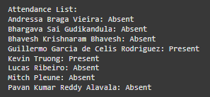
Figure 2 - List Attendance Example
Analysis and Discussion
Our first idea was to train a CNN classifier. The model achieved around 90% accuracy during both training and validation, which seemed promising at first. However, when we tested the model in real-life conditions through a live camera, it failed to recognize our faces correctly. Instead, it randomly assigned labels to people, even if they were not in the class database. We understood that the problem came from several factors. First, our dataset was too small. Some students had only one or two real photos, and even after data augmentation, the model was just memorizing details rather than learning real facial features. This led to overfitting, where the model performed well on familiar images but couldn’t generalize to new ones. Switching to FaceNet embeddings combined with cosine similarity gave us much better results. Since FaceNet was already trained on millions of faces, it could extract strong and reliable facial features even with just one clear image of a student. Instead of forcing the system to classify faces into categories, we shifted the problem to simply comparing how similar two faces were. This worked very well. The system was also fast enough to work in real time, detecting and identifying faces within a second or two, even on a regular laptop. We tested the model with both profile pictures and classroom photos, and it consistently identified students correctly.
Tools and Libraries:
- TensorFlow/Keras: Mainly for the initial CNN training. In the final system, Keras was used indirectly via the keras-facenet package.
- keras-facenet: Gave us the pretrained FaceNet model.
- MTCNN (from mtcnn library): for face detection, which performed well on our images.
- OpenCV: for image capture from camera, drawing bounding boxes and text, and general image handling.
- NumPy: for numerical operations, especially computing similarity scores and handling vectors.
- Matplotlib: we used it in the development process for visualizing training history (loss/accuracy plots) and to display example images during debugging, though it’s not part of the deployed system itself.

Strengths
Our final system has several strong points. It works well even with limited data, needing only one good image per student to function reliably. It also operates in real time, making it practical for classroom use. Adding new students is easy, we simply need to add their face embeddings to the database without retraining the whole model.

Weaknesses
However, our system also has some limitations. Since it depends heavily on the quality of the pre-trained FaceNet model, it might fail if the face is heavily occluded, for example, if someone is wearing a mask or has their face partly covered. The choice of the similarity threshold worked well for our class group, but it might need adjustments if the number or diversity of students increases. We also only tested the system on a small number of classmates, meaning it has not yet been proven on larger or more varied groups.
Future Work
If we had more time, there are several ways we could make the system better. Collecting more images for each student, with different poses and lighting conditions, would make the recognition more reliable.Trying newer models like ArcFace or using better face detectors like RetinaFace might also boost performance. Building a user-friendly interface to manage attendance records and making the system faster for recognizing multiple faces at once would make it more complete. Finally, if the system needed to scale up to hundreds of students, we would consider using faster similarity search methods or cloud-based solutions.

Conclusion
This project set out to automate classroom attendance using facial recognition, and after many trials and adjustments, we achieved a working and practical solution. We learned that trying to train a model from scratch with little data leads to overfitting and poor real-world performance. However, by switching to using pre-trained embeddings and focusing on similarity comparison instead of strict classification, we built a system that is accurate, fast, and easy to expand.
Although we only tested it on a small scale, the system proved that facial recognition can be a powerful tool to simplify tasks like attendance tracking. Future improvements could make it even more reliable for bigger groups and more varied environments. Overall, this project showed the importance of choosing the right deep learning strategy for the problem at hand and demonstrated how AI can improve everyday processes when applied carefully.

References
- Schroff, F., Kalenichenko, D., & Philbin, J. (2015, June 17). FaceNet: A unified embedding for face recognition and clustering. arXiv.org. https://arxiv.org/abs/1503.03832
- VGGFACE2: A dataset for recognising faces across pose and age | IEEE conference publication | IEEE Xplore. (n.d.). https://ieeexplore.ieee.org/abstract/document/8373813
- Deng, J., Guo, J., Yang, J., Xue, N., Kotsia, I., & Zafeiriou, S. (2022, September 4). Arcface: Additive angular margin loss for deep face recognition. arXiv.org. https://doi.org/10.48550/arXiv.1801.07698
- Labeled Faces in the Wild (LFW) Dataset: Huang, G. B., Ramesh, M., Berg, T., & Learned-Miller, E. (2007). Labeled Faces in the Wild: A Database for Studying Face Recognition in Unconstrained Environments. Official Website: https://www.kaggle.com/datasets/jessicali9530/lfw-dataset
- keras-facenet Library: keras-facenet GitHub Repository. Pre-trained Keras implementation of FaceNet. Available at: https://github.com/nyoki-mtl/keras-facenet
- Zhang, K., Zhang, Z., Li, Z., & Qiao, Y. (2016, April 11). Joint face detection and alignment using multi-task cascaded convolutional networks. arXiv.org. https://arxiv.org/abs/1604.02878
- OpenCV Documentation: OpenCV (Open Source Computer Vision Library). Official Documentation. Available at: https://docs.opencv.org/

